ROI Export and FIJI analysis from large images with QuPath
Getting QuPath Ready
- In BigBird, open QuPath
- Look at this website for info on how to use QuPath (https://qupath.readthedocs.io/en/latest/docs/starting/index.html)
- Create a project for each set of analyses
- Import the images you want to use
- Save your project
Using QuPath for Simple ROI export into ImageJ
- For each image, use the selection tool to create regions of interest for additional analysis
  - I recommend the polygon tool or the brush tool
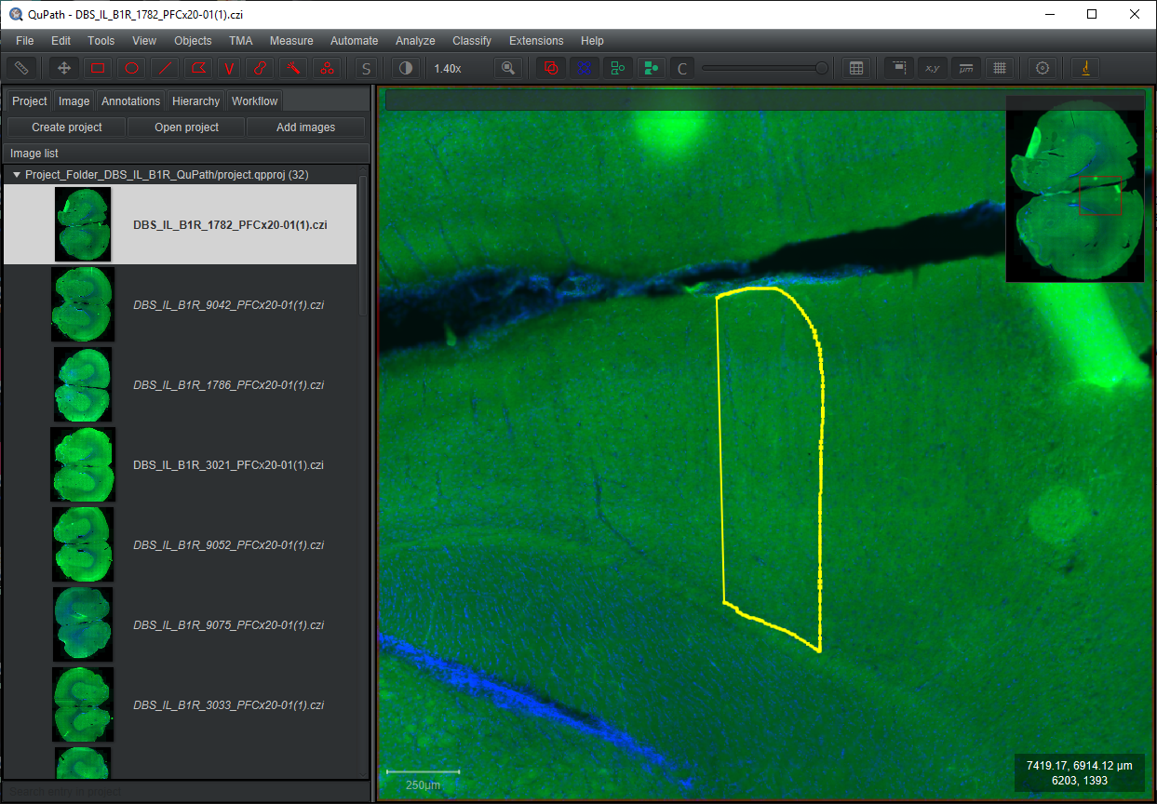
- For simple ROI export to ImageJ:
  - Whilst the “Object” is selected you can go through the window menu or the tool menu to “Send region to ImageJ” (see below)
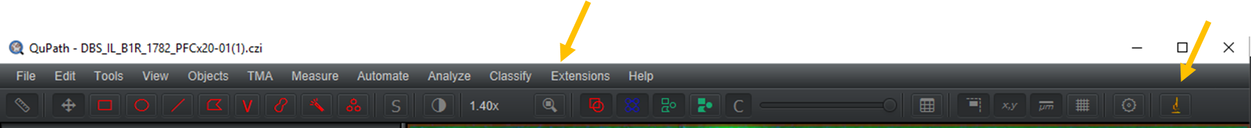

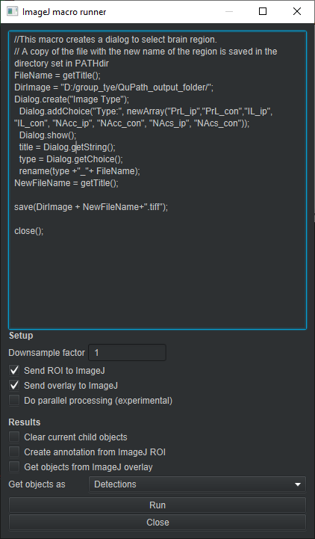
Getting QuPath ready for ImageJ Macros
- For executing macros after ROI export, there is a feature called “ImageJ macro runner”. This is useful to automate workflows previously scripted in FIJI or ImageJ.
  - Below is an example, which will export a file in a predefined directory, and rename the file based upon the from selections in an interactive dialog.
- Go to the menu “Extensions” -> “ImageJ” -> “ImageJ macro runner”
- This will open a menu, where you can paste ImageJ macros.
  - Pay special attention to the “Setup” features, the ones in the example are good for more purposes.
  - Note that holding down “alt” with the brush tool can remove selection, making it useful for cleaning up ROIs.
  - With your ROI selected, now you can select “Run” in the “ImageJ macro runner” window. This will in 1 step export the ROI based upon your settings, then it will run your macro code.

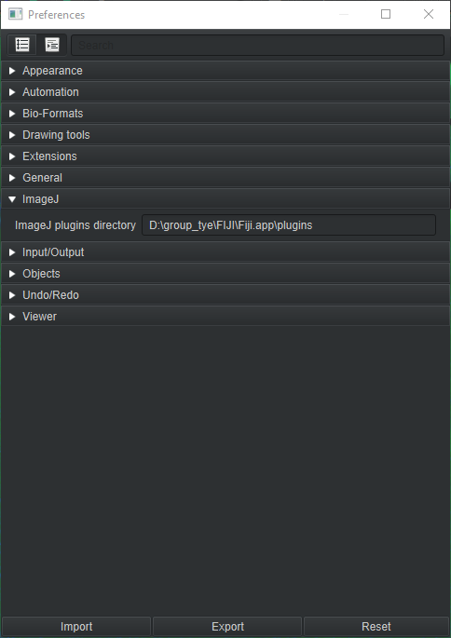
Notes:
- Exporting ROI into ImageJ may take a while and it may appear nothing is happening.
- Sometimes dialog boxes in ImageJ will be behind the QuPath windows.
- Some Plug-ins that are not default in ImageJ1 may not work. To correct for this you can set the plug-ins paths for QuPath to read macros (see example). Go to “Edit” -> “Preferences” and choose a directory in the “ImageJ” tab.

